As of 20/10/2017

This review is timed to allow the team to edit the work before the end of sprint 2, or to know what UI areas are still not up to standard/clients wishes at the end of sprint 2.

<https://www.nngroup.com/articles/ten-usability-heuristics/>

Client review of website (through use of 10 usability heuristics), and changes that should be made before end of sprint 2. Solely on the UI of the system.

Review through usability heuristics:

# Visibility of system status:

*“The system should always keep users informed about what is going on, through appropriate feedback within reasonable time.”*

In terms of system status, the main areas of focus with the ‘status’ of the system for smart city is:

* The user being logged in
* Their user type

While, like in sprint 1, the users can tell if they are logged in, and determine the page they are on through the contents of the page. The solution still does not display other information to the user through the nav bar, such as their username, user type. Information such as this should be displayed to the user to give them glanceable information while progressing through different pages.

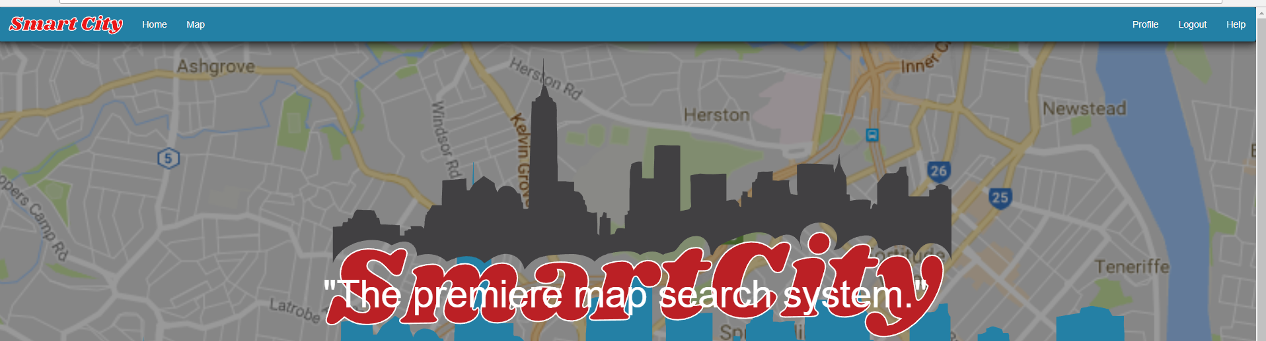

# Match between system and the real world:

*“The system should speak the users' language, with words, phrases and concepts familiar to the user, rather than system-oriented terms. Follow real-world conventions, making information appear in a natural and logical order.”*

Most of the website’s pages use language that the target audience can understand. However there are still examples of inappropriate language being used. The main area is the Profile page, where the Password prints the user’s ‘algorithm’.

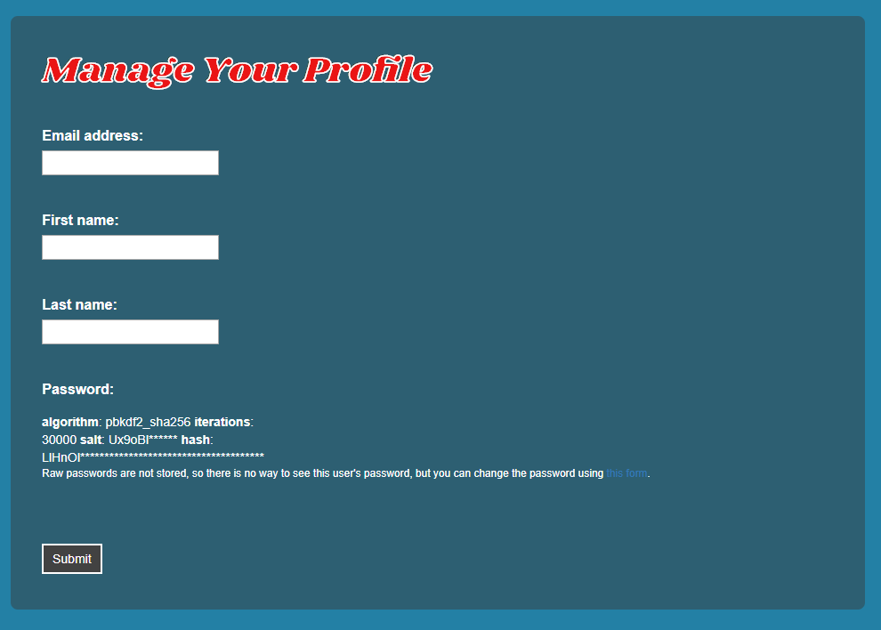

In a variety of features, there is still coding language printed instead of the final text to be displayed to the user. Such as in the maps page shown below.

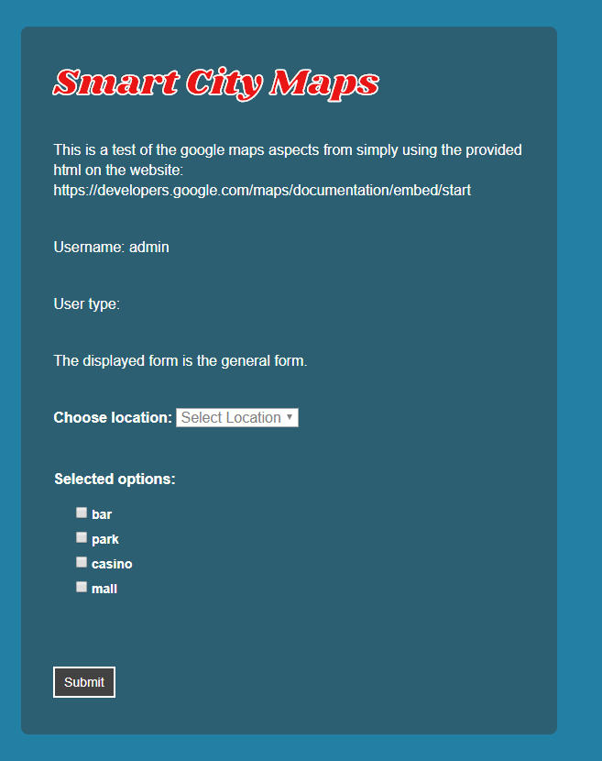

# User control and freedom:

*“Users often choose system functions by mistake and will need a clearly marked "emergency exit" to leave the unwanted state without having to go through an extended dialogue. Support undo and redo.”*

Many of the pages have no aspects where undo buttons are needed. However for the pages that do (admin creating data, users changing details). There are still no undo buttons. This is a feature that it is acceptable to not have in release one, but should be one of the main issues to fix in the next sprint, but it would also be very good to complete this in this sprint.

# Consistency and standards:

*“Users should not have to wonder whether different words, situations, or actions mean the same thing. Follow platform conventions.”*

In terms of aspects functioning as the user perceives they would, the website is fine. But for the user aspects of the website, there is a lack in the UI standards. For example most of the pages have their titles in formatted text, seen below. However the newer implemented features are yet to have the same standards applied (also shown below). This should hopefully be completed before this sprint is completed.



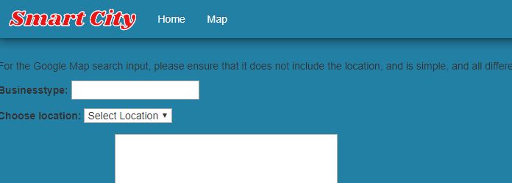

Due to scaling, the text on the main webpage moves too high when the window is full screen.



# Error prevention:

*“Even better than good error messages is a careful design which prevents a problem from occurring in the first place. Either eliminate error-prone conditions or check for them and present users with a confirmation option before they commit to the action.”*

The webpage still does not relocate users when they have a wrong URL. There should already be basic error prevention to stop simple errors such as this (redirecting users to the home page).

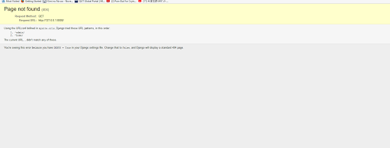

# Recognition rather than recall:

*“Minimize the user's memory load by making objects, actions, and options visible. The user should not have to remember information from one part of the dialogue to another. Instructions for use of the system should be visible or easily retrievable whenever appropriate.”*

Due to the simplistic nature of the website at this point, the user’s ability to recognise all functions

# Flexibility and efficiency of use:

*“Accelerators — unseen by the novice user — may often speed up the interaction for the expert user such that the system can cater to both inexperienced and experienced users. Allow users to tailor frequent actions.”*

# Aesthetics and minimalist design:

*“Dialogues should not contain information which is irrelevant or rarely needed. Every extra unit of information in a dialogue competes with the relevant units of information and diminishes their relative visibility.”*

The design has been updated, and the design is minimalistic, aesthetically pleasing, and overall designed well. There is only the needed information displayed to the user. And the home page’s background map/cityscape greatly add to the theme of the website.

# Help users, recognise, diagnose and recover from errors:

*“*[*Error messages*](https://www.nngroup.com/articles/error-message-guidelines/) *should be expressed in plain language (no codes), precisely indicate the problem, and constructively suggest a solution.”*

There is yet any way for users to easily fix errors themselves (besides things such as refresh the web page, etc). But there is a contact form to for users to get administrative help.

# Help and Documentation:

*“Even though it is better if the system can be used without documentation, it may be necessary to provide help and documentation. Any such information should be easy to search, focused on the user's task, list concrete steps to be carried out, and not be too large.”*

There is no aspects yes that will greatly benefit from a dedicated help section. However the team has set up a ‘help’ section so that when the time comes that more help documentation will be beneficial. It can be easily integrated.